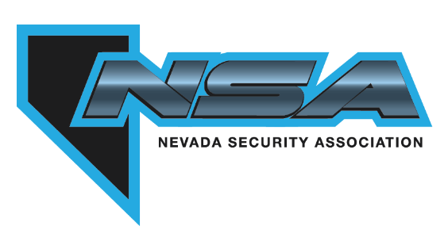
Nevada Security Association
Application for Membership

____ NEW MEMBER ____ RENEWING MEMBER

Company Name:
Address:
City: |  |  |  | State: |  |  |  |  | Zip:
Phone:
Website:
Company Voting Representative Name: |  |  |  |  |  |  | Title:
E-mail:
Billing & Contact Address if different from Voting Representative:
Contact information to appear on NSA website:
Name |  |  | E-mail |  |  |  |  | Phone
Contact information for additional company members who would like to receive NSA notices:
Name |  |  | E-mail |  |  |  |  | Phone

Services Offered by Your Company (Please check all that apply)
 | Burglar Alarms |  |  |  |  | Fire Alarms |  |  |  |  |  | Proprietary Fire Alarms
 | Access Control |  |  |  |  | CCTV |  |  |  |  |  | Home Automation
 | Biometric authentication |  |  |  |  | Video Surveillance systems |  |  |  |  |  | digital or electromechanical locks
 | Monitoring: |  |  |  |  | Through your own company
 |  |  |  |  |  | Through 3rd party central station |  |  |  | Name:
Is Central Station: |  |  |  | UL Listed Burglar |  |  |  | UL Listed Fire |  |  |  | FM Approved
 | Dealer Services |  | Company you offer services for:
 | Security Guard Services |  |  |  |  | Through your own security guards
 |  |  |  |  |  | As a subcontractor |  |  |  | Name:

Do you have all required permits & licenses? |  | YES |  | NO

Security Company General Information
(Please check and complete the following which are applicable)
 | Licensing/permitting Agency | License Type | License Number
 | NV State Fire Marshal
 | NV State Contractor’s
 | County name:
 | County name:
 | City name:
 | City name:
 | City name:
 | Other:

Please check applicable membership status:
 | REGULAR MEMBER | 2023 REGULAR MEMBER DUES $299.00
Regular Membership is open to any individual, partnership, firm, corporation or other business entity, operating within the State of Nevada which install and service electronic security and life safety systems to the general public and have a valid state/county/city/entity license to operate in those segments of the electronic security industry as the member may be operating.
 | ASSOCIATE MEMBER | 2023 ASSOCIATE MEMBER DUES $400.00
Any duly licensed business engaged in manufacturing, distributing, supplying, dealing in or selling products for services generally used, relating to, and/or necessary to the members of the Association. Also, any licensed company engaged in monitoring electronic security and life safety systems.
 | OUT-OF-STATE MEMBER | 2023 Out-Of-State MEMBER DUES $299.00
Out-of-State Membership is open to any individual, partnership, firm, corporation or other business entity, located outside the State of Nevada, who provides installation, repair and/or monitoring of electronic security systems and have a valid state/county/city/entity license in the state/county/city/entity in which it is located to operate.
 | HONORARY MEMBER |  |  | COURTESY MEMBER |  |  | LIFETIME MEMBERSHIP

AFFILIATE MEMBER
Affiliate Membership is open to any individual, partnership, firm or corporation or other business entity that does not otherwise qualify for membership under any other membership category, but has the capability of contributing significant value or expertise to the electronic security industry, or provides design, installation, service or monitoring of electronic security or life safety systems for its own use and not to either the general public or to electronic security dealers.
PAYMENT
Enclosed is payment in the amount of |  |  | $ |  | or pay by CREDIT CARD (a 3% processing fee will be added to your total)
Type of Credit Card | MC | VISA |  | AM EX |  | DISCOVER | OTHER
NAME ON CARD
ACCOUNT NUMBER
SECURITY CODE
EXPIRATION DATE
BILLING ZIP CODE

The undersigned acknowledges that all information provided in this application is true and accurate, and that false information can result in the denial of membership. Upon approval, the undersigned agrees to abide by and subscribe to the bylaws and code of ethics of the NSA. The NSA reserves the right to approve or deny membership regardless of any payments received or deposited. I hereby certify that this company meets the requirements for the indicated Membership in the Nevada Security Association.

Signature |  | Date
Print Name |  | Title

Complete all pages of this application and send with payment to
Nevada Security Association
1000 N. Green Valley Pkwy. #440-643
Henderson, NV 89074
Questions: 702-551-4NSA (4672) or info@nevadasecurityassociation.org

Please also send a high-resolution copy of your company logo

Nevada Security Association

CODE OF ETHICS

- To promote the highest standards of performance and professional conduct in the electronic security industry.

- To foster objectives founded on principles of justice and integrity that are beneficial to all persons involved in the electronic security industry and the general public.

- To deal honestly, fairly, and to be guided by a spirit of justice and honor in all matters.

- To provide mutual aid to members and to disseminate information vital to the electronic security industry.

- To encourage and support sound legislation affecting the electronic security industry.

FOR OFFICE USE ONLY:
Application Received by |  | Pymt. Received |  | Pymt processed
Licenses checked |  | Distribution list |  | Mirror ordered

